Sprint 4 Meeting Evidence
Project: Campus Food Ordering Platform
Sprint: Sprint 4
Evidence Type: Meeting screenshots and Scrum communication evidence
Meeting Screenshots Included
1. Sprint 4 Planning and Task Breakdown Meeting
Date: 12 May 2026
Duration: 25 minutes
Purpose: Sprint 4 analytics goal, task breakdown, team roles, work order, and dependencies.
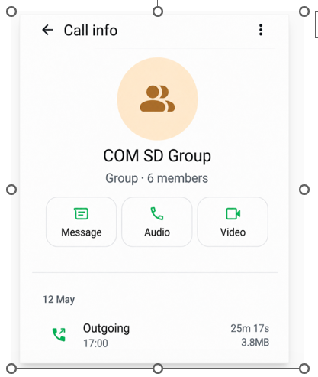
2. Sprint 4 Daily Scrum / Branch Coordination Meeting
Date: 15 May 2026
Duration: 13 minutes
Purpose: Person 1 analytics backend completion, GET /api/analytics endpoint discussion, branch coordination, and conflict prevention plan.
